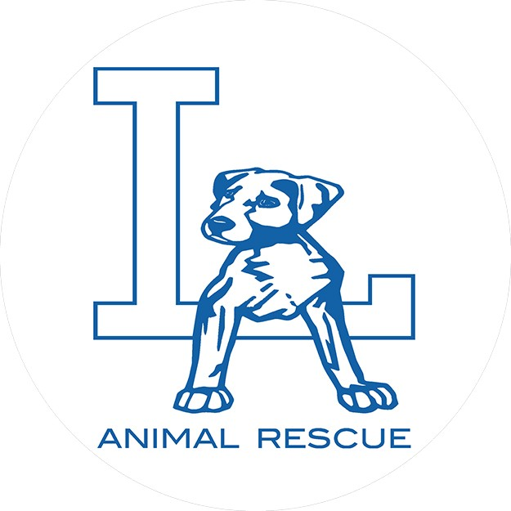
LA ANIMAL RESCUE
EST. 2010
Adoption Application

The application is the first step to see if you are potentially the right match for the animal of interest. This is not a guarantee/commitment of adoption. Our adoption process involves a home check, adoption contract & adoption fee of $350-550 for dogs depending on breed/age and $125 for cats. Adoption fees are non-refundable. Fees include spay/neuter, vaccines, de-wormer & microchip. Driver’s License information will be requested at the time of adoption. Please have it with you.
For homes with other pets, we offer a trial. Trials are typically one week. We want to make sure our dogs are happy & it’s the right match.
*NOTE: LA / Ventura County adoptions ONLY. We don’t transport our animals for their safety.

Please check DOG
CAT
Name of animal you are interested in:

Are you familiar with the breed? How did you find out about this animal?

Full name: Age: Occupation: Home address:
Phone #: Email:

Instagram handle: Facebook handle: Who will be the primary care giver for this animal? List of other people in the household with ages:

Please list other animals in the home. Include the species, breed, age AND if they are fixed or not.

If you have other pets, your vet’s name & number:

If you have other dogs, what food do you use?

Do you live in a house apartment. condo other

Does your home have any of the following (please check all that apply):
patio balcony pet door pool/jacuzzi back yard front yard

If you rent are you aware of the pet policy/fees?

Do you have regular gardeners or maintenance workers that have access to your fence/home? Will you make arrangements to ensure that your pet cannot escape while they have access?

In what areas of your home will your dog be allowed? Where will they stay when they are home alone? Where will they sleep at night? How long will the dog be left alone? When you travel who will care for your pet(s): If any behavioral issues arise, would you be willing to seek advice from a reputable trainer? Have you ever adopted an animal from a rescue before? If yes, which rescue? Have you ever surrendered or rehomed an animal? If yes, please explain:

Do you have arrangements in place for your pet(s) in the event something was to happen to you?

Are you aware that it may take some time for your new pet to decompress and adjust to their new environment?

By signing you agree that all of the information you have provided is true & correct to the best of your knowledge. You also understand that filling out the application is not a guarantee of adoption. We have a responsibility to our animals to do whatever we can to ensure they are placed in the best home possible.

Signature of applicant Date

